Genetisti Forensi Italiani

RECOMMENDATIONS ON THE COLLECTION OF BIOLOGICAL SPECIMENS FOR FORENSIC GENETIC TESTING IN THE MEDICAL LEGAL CARE OF VICTIMS OF SEXUAL VIOLENCE AND/OR ABUSE
2023 Update by the Italian speaking working group (GeFI) coordinated by Prof. Susi Pelotti

Coordinator
Susi Pelotti - Alma Mater Studiorum-University of Bologna

GeFI Board Members
Paolo Fattorini - University of Trieste Carlo Robino - University of Turin
Carla Bini - Alma Mater Studiorum-University of Bologna
Federica Alessandrini - Marche Polytechnic University
Loredana Buscemi - Marche Polytechnic University

Other Members
Filippo Barni - Department of Forensic Investigations, Carabinieri, Rome
Andrea Berti - Department of Forensic Investigations, Carabinieri, Cagliari
Andrea Piccinini - University of Milan
Sarah Gino - Eastern Piedmont University
Fabio Oldoni - Arcadia University, Pennsylvania, USA

PURPOSE
The purpose of these recommendations is to guide through the intervention of healthcare professionals involved in the collection of biological specimens from victims of sexual violence and/or abuse for forensic genetic testing purposes. The recommendations reported in this document will be incorporated into healthcare practices to provide care and support to survivors of sexual assault (DPCM Nov. 24, 2017, as amended). This protocol does not apply to preadolescent individuals except for situations in which the reported violence can be compared to cases involving adults.

MAIN SCOPE AND OBJECTIVES
These recommendations have the following main objectives:
-outline standard medical procedures for sampling of biological specimens from survivors of sexual assault and/or abuse and which the judicial authority will be able to access for the proper forensic examination/testing;
-guarantee the evidentiary value of biological specimens through proper maintenance of the integrity and continuity of the chain of custody for handling, sampling, and storage of forensic evidence;
- provide adequate medical forensic examination procedures in instances involving victims of sexual assault and/or abuse.
The recommendations reported in this document serve as the "minimum standards" that can be included in the practices of healthcare providers and response units to sexual violence and abuse.

CONSENT/REFUSAL OF FORENSIC SPECIMEN COLLECTION FOR MEDICAL LEGAL CARE PURPOSES
Informed consent from victims of sexual violence and/or abuse must be properly recorded before receiving medical care or participating in any body sampling activity, according to Law 219/2017.
- Information. Healthcare professionals—even those appointed by the Judicial Authority—must ensure that individuals seeking assistance in cases of sexual violence and/or abuse receive comprehensive and unambiguous information about the protocols for the collection of biological specimens used for forensic genetic testing. They also have to ensure that the person receiving medical assistance is given the proper attention to any question he/she may have about the reasons and procedures of the sampling process.
- Informed consent/refusal. Both acceptance and rejection of consent should be formally documented in the survivor’s medical history records. If, after being fully informed, the person does not consent to the collection of biological specimens on his or her person, clothing and personal items, healthcare professionals should record the victim’s disagreement and not proceed further with sampling.
For minors, the individuals exercising parental responsibility or legal guardianship must provide or refuse their informed consent to any medical treatment the minor receives, bearing in mind the will of the child in light of his/her age and maturity. Medical practitioners are formally required to notify those with parental responsibility or the legal representative that, should they decline to give consent for, the case will be reported to the Judicial Authority if ex officio prosecution is involved. This notification must be provided after they have been duly informed about the diagnostic hypothesis of violence and/or sexual abuse against the minor and the procedure for sampling the minor’s body sites.
Note that the Judicial Authority will have access to the biological specimens, clothing, and personal items that are collected, and they may request the necessary forensic genetic testing accordingly.

GUIDING CRITERIA FOR THE FORENSIC COLLECTION OF BIOLOGICAL SPECIMENS

A detailed examination of the circumstances surrounding the violent incident is necessary before any biological specimens can be collected. When feasible, it is important to take into account the following factors: amount of time passed between the violent event and the sample collection, how the violent act was committed, the actions that the survivor took after the assault (such as cleaning the affected anatomical parts, changing clothes, ingesting liquids, etc.), and the psychophysical state of the victim. It is reccomended to collect biological specimens from the victim for forensic DNA testing as early as possible, as the likelihood of collecting evidentiary material declines considerably over time (Table 1). It is also advisable to sample the person receiving assistance and obtain clothing and personal items in cases of prolonged mechanical immobility or as a result of the victim's impairment, or if there is no specific information available regarding the amount of time that has passed since the sexual assault or abuse occurred.

BIOLOGICAL SPECIMEN SAMPLING FOR FORENSIC GENETIC PURPOSES
It is preferable to consult a forensic genetic expert whenever possible for guidance on the handling, collection, and preservation of biological evidence given the unique nature of forensic DNA testing. Biological specimens (blood, semen, and saliva stains, hair formations, sweat and epidermal cells) can be collected on different body sites which include:
A - the body of the sexual assault victim: To ensure consistency in the sampling process, it is recommended that sterile swabs be taken in duplicate at the same spot. (refer to Annex 1). Samples need to be obtained from the mouth, perioral, vaginal, anal, and penile regions as well as from any other site of the body where the sexual assault victim has been physically touched or bitten by the (alleged) offender. The collection of biological samples intended for use in forensic genetic testing typically occurs before those included in the clinical care protocol, pending the fulfilment of clinical prerequisites for the victim’s health protection.
  - Oral swabs. Two dry swabs should be taken one after the other, with specific attention to rub them in the area between the teeth and the lower buccal vestibule; these must be initialed in chronological order of completion.
  - Skin swabs. Two swabs slightly moistened with saline or sterile water (one or two drops) should be rotated on their axis and simultaneously swiped on the skin once the site of potential contact or visible trace has been identified. Sampling devices consisting of two swabs are commercially available. If these are unavailable, use two distinct swabs, possibly coupled to guarantee consistency in the sampling process; these must be used simultaneously in the body sites that allow it and must be stored separately.
  - External genital swabs (labia majora and labia minora). Two swabs slightly moistened with saline or water sterile (one or two drops) are used, one after the other, to sample the inner surface of the labia majora and minora, and are initialed in the sequence in which they were completed. This sampling step needs to be performed before the cervical and vaginal swabbing.
  - Vaginal swabs (preferably at the proximal third of the vaginal canal). Two dry swabs are taken in the same location, one after the other, and they are initialed in the order that they were completed chronologically by repeatedly rotating them along the walls and on their axis. It is recommended to perform these vaginal swabs before cervical swabs.
  - Cervical swabs. Two dry swabs are successively taken with the speculum in the cervical canal. The swabs are initialed in the order that they are completed chronologically, and the speculum is sampled.
  - Perianal swabs. Two dry swabs are successively rotated on their axis and rubbed on the anal orifice's margin, then initialed in the sequence in which they were completed.
  - Rectal swabs (preferably at the proximal third). Two dry swabs are used sequentially and they are rotated on their axis several times before being initialed in the order that they were taken.
  - Penile swabs (balano-preputial groove, glans, penile shaft). Two swabs lightly wet with saline or sterile water (one or two drops) are used and swiped over each region sequentially by rotating them on their axis and initialed in the order that the areas were sampled.
  - Hair formations. Collect fibers, hairs from the sexual assault victim’s head, and hairs from the victim’s body with sterile tweezers. Then, place the materials in sterile containers (such as urine jars), making sure to divide them according to the body site being sampled (one container per each sampled area). Cut a few centimeters around the area of interest if biological fluids (such as saliva or semen) are visible on the hair or pubic hair; if the victim gives no consent, proceed with sampling using a swab.
  - Sub-ungual material. It is preferable to use thin-tipped swabs underneath the free edge of each nail (avoid needles or sharp instruments). Each swab from each finger should be kept in an individual tube. If possible, avoid cut the nail; if cutting is required, clean the scissors before and after each sample using a solution containing sodium hypochlorite, which will then be dried with paper. Store each nail sample in a single sterile tube (refer to Appendix 1).

Please note: Other biological specimens could also be found at the place where the violent incident occurred: these are special situations that involve the intervention of the Judicial Authority and/or law enforcement agency. The healthcare practitioner responsible for gathering the circumstantial data must notify the Judicial Authority and/or law enforcement agency of this possibility based on the narrative disclosed.

B - clothing: Biological specimens on clothing are not always visible to the naked eye. All clothing worn at the time of the event should therefore be collected, with particular regard to underwear and any intimate pads, diapers, or whatever is in contact with the intimate regions, which, if found attached to the garment, should not be detached (refer to Table 2 for further information).

Please note: If the person receiving assistance claims to have changed cloths, it is preferable to obtain clothing she/he is currently wearing, especially the underwear, and advise her/him to preserve (without washing) the items worn at the time of the incident should they need to be turned in either directly to law enforcement or indirectly through medical staff.

C - other material of interest: Items such as handkerchiefs, condoms (including female condoms), and speculum should be collected, placed in appropriately sized containers (e.g., disposable falcons, Petri dishes, jars), and stored in the freezer at -20°C. In the instance of condoms, in particular, it is instructed to seal the end of the condom (e.g., by knot) to prevent the leakage of any seminal fluid. Caution: it is mandatory to change gloves after this operation. Since it is also possible to generate genetic profiles in the absence of sperm cells from swabs (vaginal, rectal, etc.), setting up microscope slides for sperm detection is not necessary for forensic genetic testing. As microscope slides used for genetic analysis can also be set up for other diagnostic purposes, samples should be stored in suitable containers to prevent contamination and maintain the integrity of the chain of custody (refer to Table 2 for further information).

D - In case of voluntary termination of pregnancy, miscarriage, or childbirth related to violent events, healthcare personnel (gynecologist/obstetrician) must proceed to the collection of abortion material, placenta, fetal funiculus, and neonatal blood. Abortion/placenta/funiculum material should be stored in separate and sterile containers under the driest possible conditions, avoiding excess blood and without preservative liquid (e.g., formalin or saline), and frozen at -20°C. Avoid oversized containers so that they can be stored in the freezer. In case of childbirth, take a few drops of neonatal blood to be affixed to bibula paper (e.g., Guthrie card) (refer to Table 2 for further information).

Table 1. Summary table on the procedures used to collect biological specimens from a sexual assault victim’s body (section A).

Body site | Maximum time interval after offense¹ | Method of sample collection |  |  |  | Method of intimate sample storage
 |  | How many? | What kind? | How? | Where
Oral cavity | - 48 h (2 days) | 2 | Dry swabs² | One after another,  initialed  chronologically | Rub the gaps between the teeth and the lower buccal vestibule | - Store each sample in its case/container which should be initialed with the case identifier, specimen, and date of collection  - Place the samples taken for each body site in a separate envelope, initialed with case ID, sealed, and countersigned  - Place all envelopes related to a specific case in a single envelope of appropriate size also bearing the case ID, sealed and countersigned  - Freeze the bag at -20°C (Note: you can temporarily store samples for up to 24 h in the refrigerator at 4-8° in case the freezer at -20°C is unavailable)
Skin (including perioral skin, inter-femoral skin, scrotum) | - 48 h (2 days), but up to 168h (7 days) in unwashed areas | 2 | Moistened³  swabs² | Simultaneously | Rub the surface of referred/visible contact, rotating the pads on their axis  Note: in case of bite marks or wounds, samplings precede wound dressing unless there are clinical needs
External genitalia | - 168 h (7 days) if reported ejaculation on external genitalia or vaginal intercourse  - 72h (3 days) if reported anal intercourse  - 48h (2 days) if reported digital penetration or skin contact | 2 | Moistened³  swabs² | One after another,  initialed chronologically | Rub the inner surface of the labia majora and labia minora, rotating the pad on its axis  Note: perform before vaginal and cervical swabs
Vaginal cavity | - 168 h (7 days) if reported ejaculation on external genitalia or vaginal intercourse  - 72h (3 days) if reported anal intercourse  - 48h (2 days) if reported digital penetration or skin contact | 2 | Dry swabs² | One after another,  initialed chronologically | Rub repeatedly on the walls of the proximal third of the vaginal canal, rotating the swab on its axis  Note: perform before cervical swabs
Cervix | - 168 h (7 days) if reported ejaculation on external genitalia or vaginal intercourse  - 72h (3 days) if reported anal intercourse | 2 | Dry swabs² | One after another,  initialed chronologically | Using a speculum, rub into the cervical canal, rotating the swab on its axis
Perianal region | - 168 h (7 days) if reported ejaculation on external genitalia or vaginal intercourse  - 72 h (3 days) if anal intercourse reported  - 48 h (2 days) if reported digital penetration or skin contact | 2 | Moistened³  swabs² | One after another,  initialed chronologically | Rub the margin of the anal orifice, rotating the swab on its axis
Rectum | - 72 h (3 days) if anal intercourse reported  - 48 h (2 days) if reported digital penetration | 2 | Dry swabs² | One after another, initialed  chronologically | Rub repeatedly on the walls of the proximal third of the rectal canal, rotating the swab on its axis
Penis | 72 h (3 days) | 2 | Moistened³  swabs² | One after another,  initialed chronologically | Rub the balano-preputial groove, glans, and penile shaft, rotating the pad on its axis
Individual hair formations | - Unlimited when applicable to the event | // | Sterile tweezers | // | Collect hair formations broken down by sampling body site
Body fluids on hair formations | - Unlimited if visible body fluids  - 72 h (3 days) if reported skin contact | // | Cutting with scissors | Decontaminating⁴ the scissors  after each collection | Take a section of hair(s) extended a few centimeters around visible trace or area of reported contact
 |  | 2 | If the subject does not consent to cutting,  moistened² swabs³ | Simultaneously | Rub surface at visible trace or area of reported contact, rotating pads on their axis
Subungual spaces | 48 h (2 days) | 1  per finger | Dry swab²,  preferably thin tipped | // | Rub under the free edge of the nail.
 |  | // | Alternatively,  cut with scissors | Decontaminating⁴ the  scissors after cutting  each nail | Collect the nails individually

Notes
¹ Even in the case of protected relationships
² Swabs: sterile "dry" type without culture medium or other preservation solutions
³ To moisten the swabs: use one/two drops of saline solution or sterile water
⁴ To decontaminate no disposable objects (e.g., scissors), wash them with sodium hypochlorite and dry them thoroughly after each sampling.

Table 2. Summary table on the procedures used to collect the victim’s clothing and other material of interest (section B, C, D).

Body site | Maximum time interval after offense¹ | Method of sample collection
Clothing (if worn at the time of the incident and based on the victim’s narrative) | - Unlimited | Have the sexual assault survivor undressed on a sterile towel or paper sheet to be stored separately in a paper bag at room temperature.  Air dry damp or wet garments and store them individually in paper bags or cardboard boxes (one per garment, initialed with case ID, sealed, and countersigned) at room temperature.  If it is impossible to dry the garments, store them individually in plastic bags or containers (one per garment, initialed with case identification, sealed, and countersigned)  Freeze them as soon as possible at -20°C (you can temporarily store them for up to 24 h in a refrigerator at 4-8°).
Objects (tissues, condoms, speculums, etc.) | - Unlimited, if bearing obvious or likely traces | Place them in sterile containers of appropriate size (e.g., disposable falcon, jars, etc.) and store them in freezer at -20°C. In the case of a condom, it is specified to close the end of it (e.g., by knot) to prevent leakage of any seminal fluid (note: after this procedure, it is mandatory to change gloves).
IVG, miscarriage,  childbirth | // | Proceed to retrieval of abortion/placenta/fetal material (IVG, miscarriage) and neonatal blood (childbirth).  Abortion material/placenta/funiculum should be placed individually in sterile containers of appropriate size, avoiding excess blood, without preservative liquid (e.g., formalin or saline), and frozen at -20°C. In case of childbirth, take a few drops of neonatal blood to be affixed on bibula paper (e.g., Guthrie card) to be dried and stored at room temperature.

Notes
¹ Even in the case of protected relationships.
² Swabs: sterile "dry" type without culture medium or other preservation solutions.
³ To moisten the pads: use one/two drops of saline solution or sterile water.
⁴ To decontaminate no disposable objects (e.g., scissors), wash with sodium hypochlorite and dry thoroughly after each collection.

GENERAL PROCEDURES ON SPECIMENS SAMPLING FOR HEALTHCARE PRACTITIONERS
All healthcare practitioners must compulsorily wear personal protective equipment, adopt all procedures aimed at avoiding contamination events (personnel-specimen contamination, specimen-specimen contamination, environment-specimen contamination), and ensure the integrity and proper handling, storage, and traceability of the evidentiary material collected.
A caregiver is responsible for the material collected during the collection stages, thus avoid leaving the victim unattended at the outpatient clinic while samples are being taken. In the event of an injury, such as a bite or wound, it is crucial to discuss with the clinician whether samples of forensic genetic relevance can be obtained before the wound is healed, and if that is possible, take metric-referenced photographic surveys per DPCM 24/11/2017 guidelines.
Oral swabbing should be considered in the event of oral penetration, and this should be discussed with the clinician as soon as the anamnestic data is obtained and before the victim ingests any oral fluids.
A - Body of the sexual assault victim
- Wear a lab coat, hair net, mask, and gloves (the latter to be replaced after each sampling).
- Use dry and sterile cotton-tipped applicators or synthetic swabs equipped with their hard case (e.g., oral-pharyngeal tube sampling type) without culture medium or other storage solutions.
- Moisten swabs with saline or sterile water when sampling on dry surfaces (perioral region, skin regions, external genitalia, perianal, penile). It is not necessary to moisten swabs for sampling in anatomical regions that are moist by their nature (oral cavity, vagina, cervix, rectum). Store the swabs in their hard case.
- All containers used to store the biological material collected must be labelled with initials, case identifier, specimen or anatomical region of sampling, and date of sampling.
- Place the swabs collected (swabs, hair formations, nails/subungual material) for each body site preferably in a single envelope (one envelope per each body site sampled) bearing the case identifier, which should be sealed and countersigned. Each envelope related to the particular case should be gathered into a single, suitably sized envelope bearing the case identifier and which should also be sealed and countersigned.
- Freeze the bag as soon as possible at -20°C (refer to chain-of-custody form also for temporary storage).
- Make a list of all evidentiary materials collected (refer to "sampling sheet").

B - Clothing of the sexual assault victim
- Wear a lab coat, hair net, face mask, and gloves (the latter are to be replaced each time a garment is handled/sampled).
- To gather any material from clothing or the body, have the sexual assault victim undress on a sterile towel or paper sheet. If the individual wears the clothing worn at the time of the incident, help the person receiving assistance undress to prevent any contamination. It is further recommended to store the sterile drape or paper sheet separately in a paper bag at room temperature.
- Handle items of clothing with caution as they may carry biological material from the aggressor, fibers, hair formations, or other materials; fold them carefully on themselves and check for moist stains. For packaging, transportation, and storage (refer to chain-of-custody protocols):
  - if possible, air-dry undried garments without using heat sources (stoves, heaters, hair dryers, etc.); store well-dried garments individually in new paper bags (one paper bag for each garment item) or cardboard boxes (one box for each garment item), and store them at room temperature;
  - if it is not possible to dry the garments, promptly freeze them at -20°C after placing them in separate plastic bags and/or sterile plastic containers (one bag/container per each garment item).
- Do not use the refrigerator to store specimens for more than 24 hours, as the internal temperature (i.e., 4°- 8° C) is unsuitable for long-term storage of biological specimens. The 4°- 8° C refrigerator can be used as a temporary storage option before freezing them later for long-term storage.
- Paper envelopes, cardboard boxes, and security envelopes should be sealed (refer to note 1) and labeled with the case identifier, exhibit identifier, and date of collection (do not report last name and first name).
- Make a list of all materials collected (refer to "sample collection sheet").

¹ Methods for sealing the envelopes, especially the envelope containing all the collected material, include the use of the security envelope with tamper-evident closure, if available, or the plastic envelope for biological material, which should be sealed with tamper-evident adhesive label or adhesive label countersigned on the flaps. Similar tamper-resistant adhesive tapes or labels should be used to seal the paper envelopes.

PAPERWORK TO BE COMPLETED AT THE SPECIMEN SAMPLING STAGE
It is recommended, subjected to the internal policies of each healthcare provider facility, to:
- Draft the collection sheet and outline all procedures related to the sampling of relevant body samples and clothing/other material of interest;
- Include the following sentence in the medical records of the sexual assault victim (ER report, medical record, or outpatient certificate) and any crime report, if there is a requirement for the medical practitioner to draft one: "A collection sheet including evidence samples has been created in case forensic genetic testing is required."
- Prepare a chain-of-custody form, allowing traceability of the evidence (delivery-custody), which must be countersigned by the healthcare provider who took charge of the sexual assault victim. This record must contain the identifying information about the case, date of the tasks completed, and details of the caregiver. The documentation must follow the evidentiary items and must be updated with subsequent handover actions. It is recommended to set up a checklist of the tasks completed.

Bibliographic references (last accessed 29.11.2023)

- Ministry of Health & Family Welfare Government of India (2015). Guidelines & Protocols Medico-legal care for survivors/victims of sexual violence. https://main.mohfw.gov.in/reports/guidelines-and-protocols-medico-legal-care-survivors-victims-sexual-violence
- World Health Organization & UNODC (2015). Strengthening the medico-legal response to sexual violence. https://iris.who.int/handle/10665/197498
- Scientific Working Group on DNA Analysis Methods (2016). Recommendations for the efficient DNA processing of sexual assault evidence kits. https://www.swgdam.org/_files/ugd/4344b0_4daf2bb5512b4e2582f895c4a133a0ed.pdf
- The Faculty of Forensic & Legal Medicine of the Royal College of Physicians (2023). Recommendations for the Collection of Forensic Specimens from Complainants and Suspects, July 2023 version.
https://fflm.ac.uk/resources/publications/recommendations-for-the-collection-of-forensic-specimens-from-complainants-and-suspects/
- National SART Guidelines Development Group (2023). National guidelines on referral and forensic clinical examination following rape and sexual assault (Ireland), 5th edition.
https://www.hse.ie/eng/services/publications/healthprotection/sexual-assault-response-team-national-guidelines.pdf

Acknowledgements

We are grateful to the Police Bureau of Forensic Services for their assistance in putting this material together.

ANNEX 1.

COLLECTION OF SKIN SAMPLES FROM THE BODY OF THE SEXUAL ASSAULT VICTIM

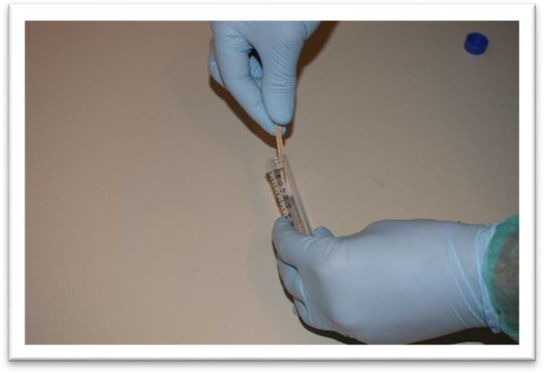
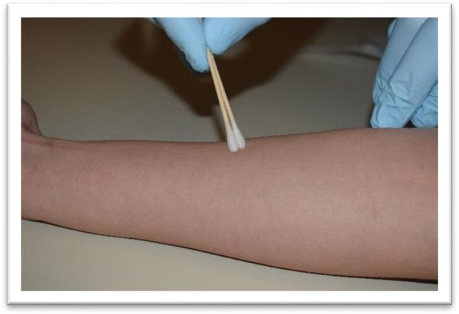
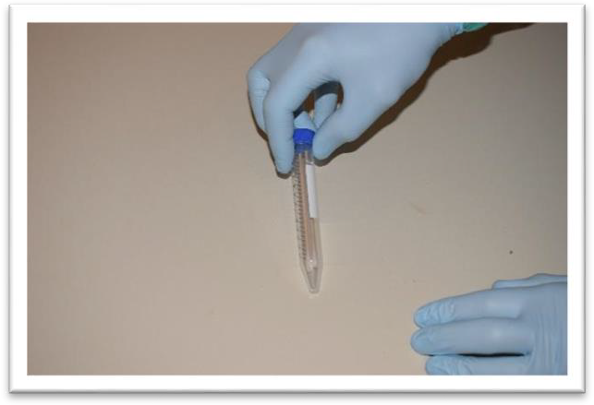
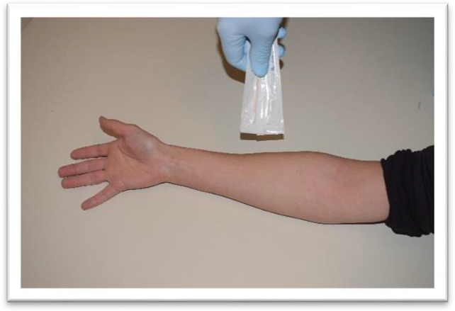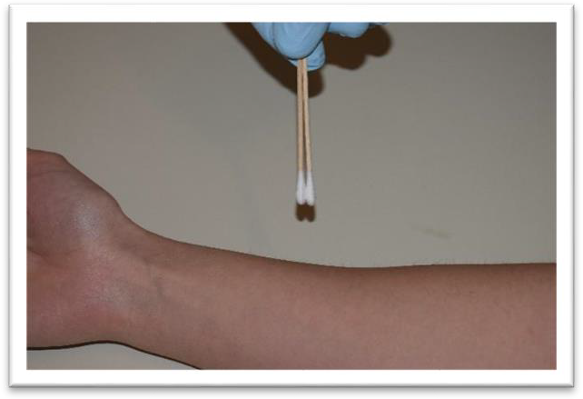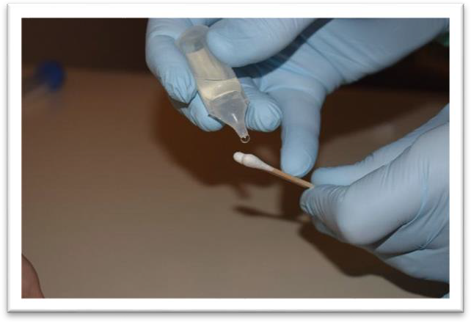

COLLECTION OF SUBUNGUAL MATERIAL FROM THE SEXUAL ASSAULT VICTIM
